ONE TRAGEDY, TWO VICTIMS
一个悲劇，兩個受害者

February 10, 2015, Indicted
February 11, 2016, Convicted
Save former NYPD Police Officer Peter Liang from unjust scapegoating
Nationwide Protest on Feb.20, 2016

2月20 日全美聲援梁警官丹佛大游行

今天我們沉默
明天我們的孩子将成为替罪羊
呼應全美大游行， 为我們孩子的未来發聲！
Join the Protest, for the future of our children!

游行地點和時間 / Location and Time:
Civic Center Park
100 W 14th Ave Pkwy
Denver, CO 80204
February 20 (星期六) 1:00PM-3PM

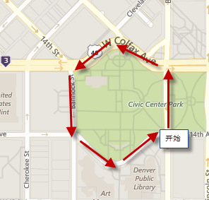

交通工具: 轻铁 / Transportation: Light Rail
Take light rail according to your location to get to Union Station or 16th Street. Then take the free shuttle to Civic Center Park.
請根據你的所在地乘坐轻铁到Union Station or 16th Street， 再坐免費的巴士到Civic Center Park.
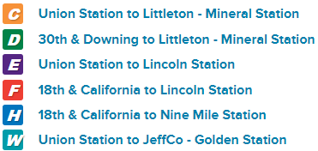

停車場/Parking：https://www.parkme.com/denver-parking/civic-center-park

口號/Slogans:
Justice for Liang, Justice for all!
One Tragedy, two Victims!
No Double Standards!
Fair Trial for Liang!
Shame on NYPD!

注意事項與規則/Rules：
1. 请遵守科州華人聯盟的領導，注意安全。
Please follow the lead of Colorado Chinese American Alliance committee. Take safety measures.
2. 请參照科州華人聯盟的宣傳材料；如有傳媒問起，請引見我們的媒體發言人周勇和 華清。
Refer to Colorado Chinese American Alliance’s official handouts; direct all media requests to our spokesman Yong Zhou and spokeswoman Qing Hua.
3. 鼓励大家自带美国国旗，其他國家國旗嚴禁。
Only American Flags are allowed during the Protest.
4. 请大家注意言词，控制情緒，游行期间嚴禁內訌與爭吵。
Personal conflicts are prohibited during Protest.
5. 無暴力， 謾罵 ，或著違法行為。違法者后果自負。
No violence, cursing or any kind of unlawful acts. Take full responsibility for any unlawful acts.
6. 隻在人行道上， 不能在街上。
Stay on the sidewalks, avoid streets.
7. 遵守交通規則，不堵路，禮讓行人，清理自己的垃圾。
Let pedestrians go first, do not block traffic or littering.

Disclaimer: Individuals are responsible for their own safety and actions. Colorado Chinese American Alliance shall not be liable for any damage or injury of any participants. By joining the Protest all participants agree to follow the rules set forth above. Colorado Chinese American Alliance reserves the right to ask anybody to leave the Protest or be excluded. The official handouts of Colorado Chinese American Alliance bear the organization’s official statement.

注更多信息/More Information: http://savepeterliang.org/

